# Họ và tên: Trần Minh Triết

# MSSV: SE172241

# Class: IA1702

# Question:

**What is Blind Command Injection, and how does it differ from classic command injection vulnerabilities?**

Blind Command Injection is a type of security vulnerability that occurs when an application or system allows an attacker to inject malicious commands into a data entry point (e.g., a web form, URL parameter, or input field) and execute them on the underlying system. The key difference between Blind Command Injection and classic Command Injection lies in the feedback mechanism provided to the attacker.

In a classic Command Injection vulnerability, the attacker can directly observe the results of their injected commands. For example, if a web application takes user input and constructs a system command without proper validation or sanitization, an attacker might inject additional commands to be executed. The attacker can see the output or error messages directly on the web page, enabling them to gather information about the system and potentially exploit it further.

In Blind Command Injection, the attacker does not receive immediate feedback on the results of their injected commands. Instead, the application typically does not display the command output or error messages directly on the web page. This lack of feedback makes it more challenging for the attacker to gather information about the system's response.

Blind Command Injection vulnerabilities are often categorized into two types:

Blind/Time-Based Payloads: In this scenario, the attacker injects commands that cause delays or wait for specific conditions (e.g., using sleep commands). By observing the time it takes for the application to respond, the attacker can infer whether the injected command was successful.

Blind/Boolean-Based Payloads: Here, the attacker injects commands that affect the logical conditions of the application. The attacker can then infer the success or failure of the injected command based on changes in the application's behavior. For example, they might inject a command that, if successful, causes the application to respond with a true condition (e.g., a particular message or behavior).

Mitigating Blind Command Injection vulnerabilities involves validating and sanitizing user input, using parameterized queries, and implementing proper input validation checks to ensure that only expected and safe inputs are processed. Additionally, employing web application firewalls and regularly updating and patching software can help protect against these types of vulnerabilities.

**Discuss the challenges posed by Blind Command Injection, particularly in scenarios where the application does not return any direct output from executed commands. How can an attacker infer successful command execution in such cases.**

Blind Command Injection poses unique challenges for attackers when the application does not return direct output from executed commands. In such scenarios, attackers must rely on indirect methods to infer whether their injected commands were successful. Here are some common challenges and techniques used by attackers in Blind Command Injection:

Limited Feedback: Without direct command output, attackers face a lack of feedback, making it difficult to ascertain the success or failure of injected commands. They cannot directly observe the results, which increases the complexity of the attack.

Time-Based Techniques: Attackers often resort to time-based payloads, where they inject commands that cause delays (e.g., sleep commands). By measuring the time it takes for the application to respond, they can infer whether the injected command was executed successfully. Longer delays might indicate success, while shorter delays suggest failure.

Boolean-Based Techniques: In scenarios where time delays are not practical, attackers may use boolean-based payloads. They inject commands that affect the logical conditions of the application. For instance, they might inject a command that, if successful, alters the application's behavior, leading to a true condition. By observing changes in the application's responses or behavior, attackers can deduce the success or failure of their commands.

Out-of-Band (OOB) Techniques: In some cases, attackers may resort to out-of-band communication to confirm the success of injected commands. For example, they might inject commands that trigger DNS requests or HTTP requests to a server under their control. Monitoring these external interactions can help attackers determine whether the commands were executed.

Error-Based Techniques: Even without direct output, error messages can sometimes provide clues. Attackers may inject commands that intentionally cause errors or exceptions. The presence or absence of error messages in the application's response can indicate the success or failure of the injected commands.

Brute-Force and Iterative Testing: Due to the lack of direct feedback, attackers may need to adopt a trial-and-error approach, systematically injecting commands and observing the application's behavior over time. This iterative testing can be time-consuming but may eventually lead to successful exploitation.

Mitigating Blind Command Injection requires a combination of secure coding practices and input validation. Developers should implement proper input sanitization, validate and filter user inputs, and use parameterized queries to prevent command injection vulnerabilities. Regular security audits, penetration testing, and monitoring for unusual or suspicious behavior can help identify and address Blind Command Injection risks in a timely manner.

**Lab 13: Blind OS command injection vulnerabilities**



Use Burp Suite to intercept and modify the request that submits feedback.



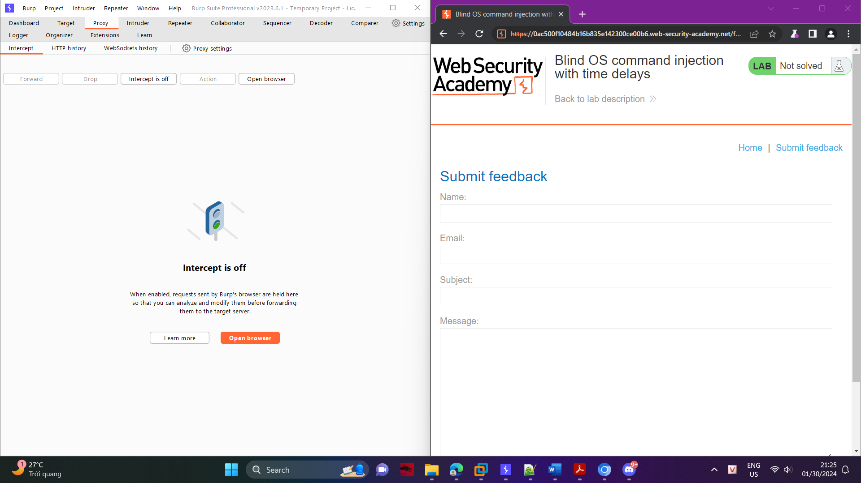

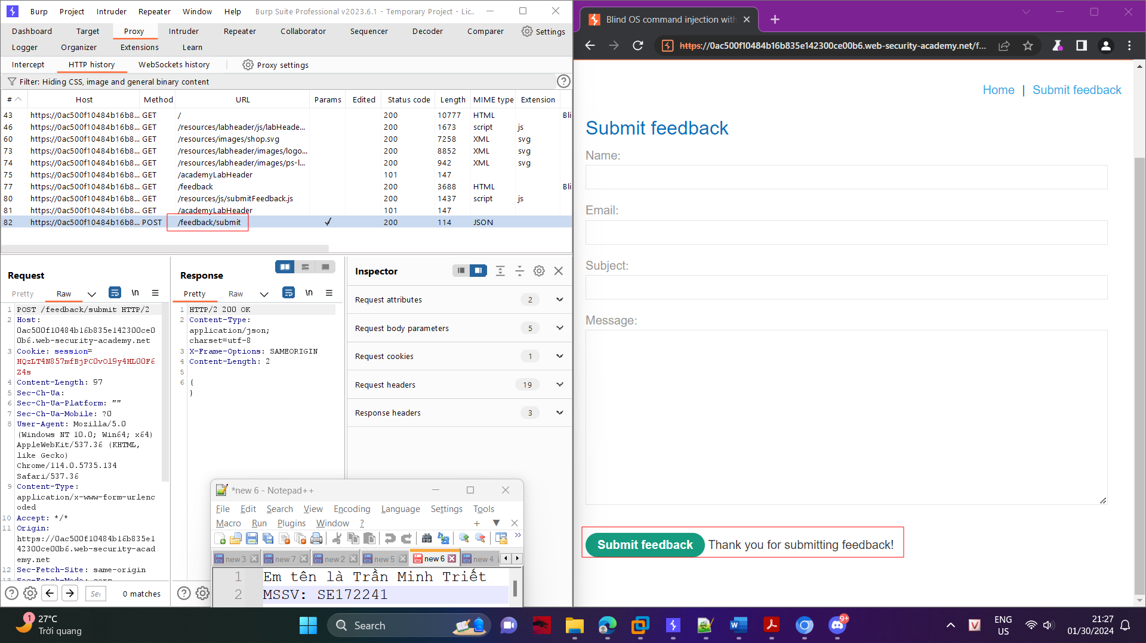

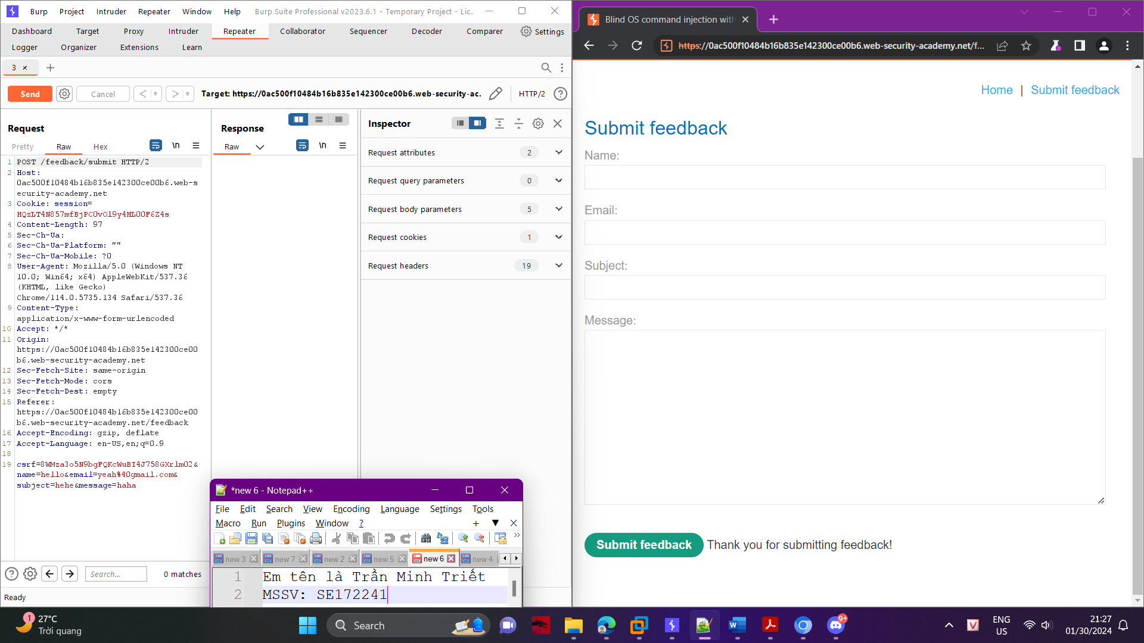

Modify the email parameter, changing it to:

email=x||ping+-c+10+127.0.0.1||

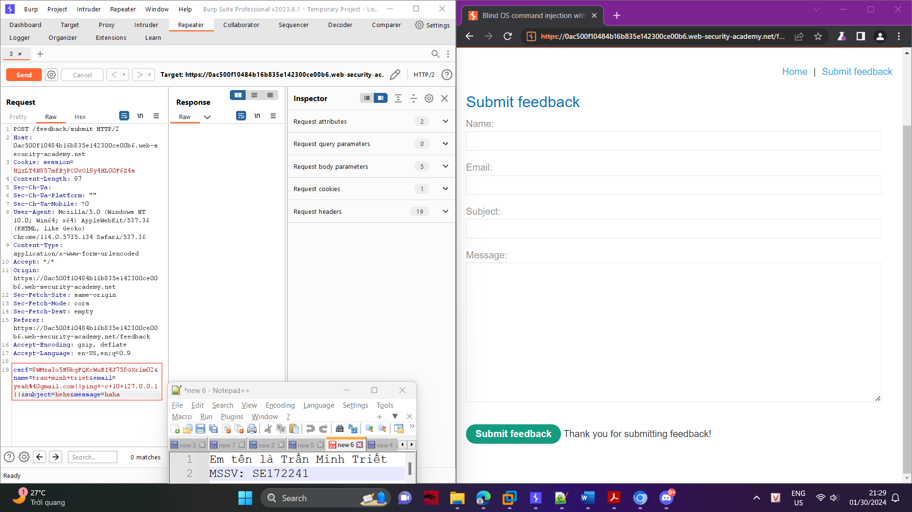

Observe that the response takes 10 seconds to return.

